SUBCOURSE EDITION
IT0113 D

US ARMY INTELLIGENCE CENTER

REPORTING AND DISSEMINATING

INTELLIGENCE INFORMATION

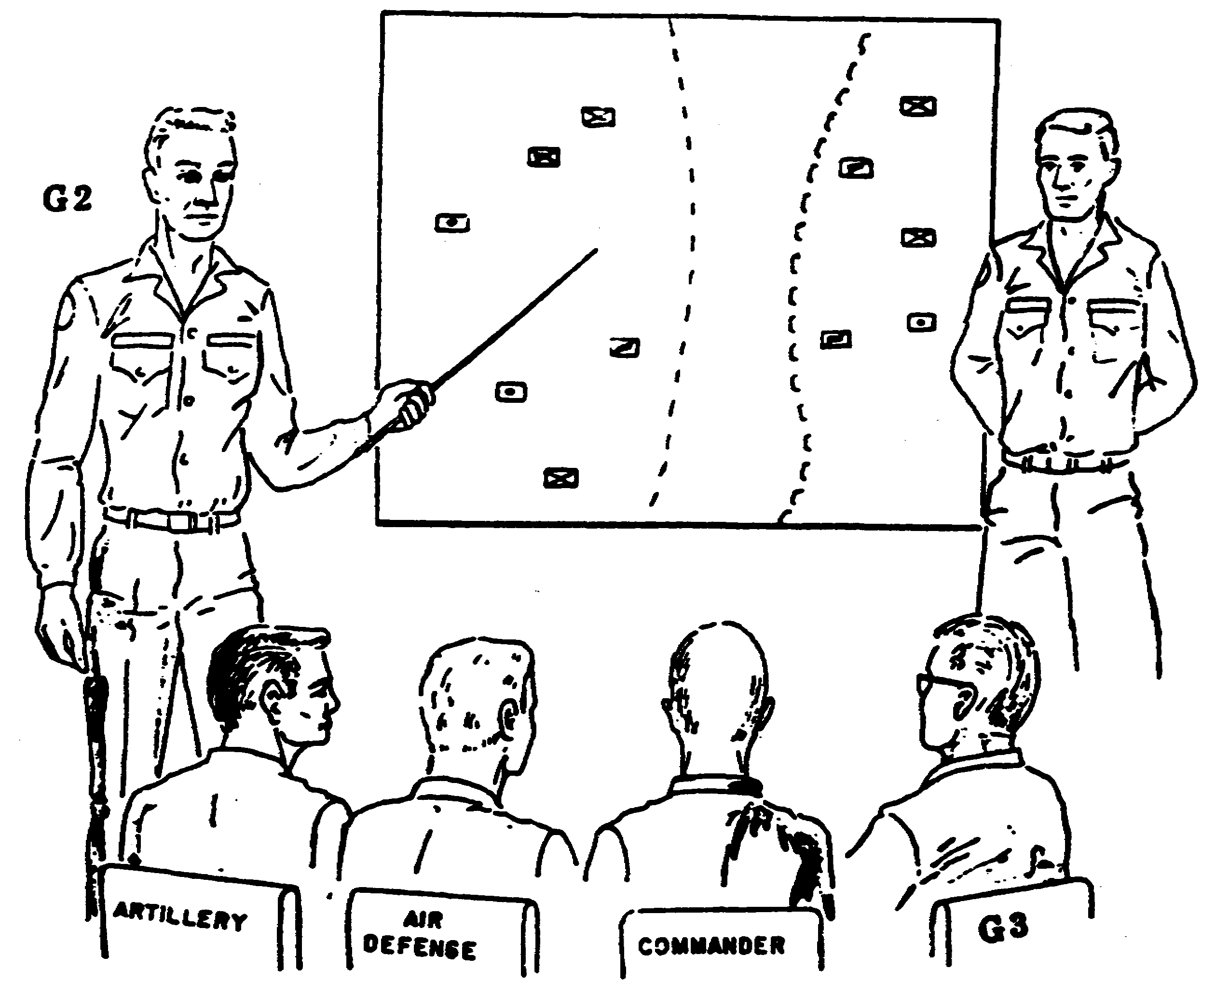



REPORTING AND DISSEMINATING INTELLIGENCE INFORMATION

Subcourse Number IT0113

EDITION D

United States Army Intelligence Center
Fort Huachuca, Arizona 85613-6000

10 Credit Hours

Edition Date: September 1998

SUBCOURSE OVERVIEW

This subcourse is designed to teach you about the suggested format and time frame for eight intelligence reports, the most common types produced in the Army today. It also teaches approved means of distributing these reports.

There are no prerequisites for this subcourse.

This subcourse reflects the doctrine which was current at the time the subcourse was prepared. In your own work situation, always refer to the latest publications.

The words “he,” “him,” his,” and “man,” when used in this publication, represent both the masculine and feminine genders unless otherwise stated.

TERMINAL LEARNING OBJECTIVE

ACTION: Prepare various intelligence reports, and disseminate intelligence information reports.

CONDITION: Given this subcourse and a pencil.

STANDARD: To demonstrate competency to this task, you must achieve a minimum of 70% on the subcourse examination.

i IT0113

TABLE OF CONTENTS

Section Page

Subcourse Overview

Lesson 1: Intelligence Reports Preparation 1-1
Part A: Intelligence Summary 1-2
Part B: Intelligence Estimate 1-4
Part C: Intelligence Annex 1-6
Part D: Periodic Intelligence Report 1-9
Part E: Situation Report 1-10
Part F: Situation Overlay 1-11
Part G: Analysis of the Area of Operations 1-11
Part H: Intelligence Briefing 1-13
Practice Exercise 1-20
Answer Key and Feedback 1-22

Lesson 2: Intelligence Information Report Dissemination 2-1
Practice Exercise 2-11
Answer Key and Feedback 2-12

Appendix A: Intelligence Estimate A-1

Appendix B: Sample Intelligence Annex B-1

Appendix C: Format/Explanation of PERINTREP C-1

Appendix D: Sample OB Annex to PEPINTREP D-1

Appendix E: Sample Situation Report E-1

Appendix F: Sample Map Overlay with Marginal Information F-1

Appendix G: Sample Analysis of the Area of Operations G-1

Appendix H: Acronyms H-1

IT0113 ii

LESSON 1

INTELLIGENCE REPORTS PREPARATION

CRITICAL TASKS: 301-372-2025
301-372-2100
301-372-2101
301-372-2151
301-372-2204
301-372-3015
301-372-3150
301-372-3151
301-372-3202
301-372-3254
301-372-3255

OVERVIEW

LESSON DESCRIPTION

This lesson will teach you the prescribed and/or suggested format for preparation of the most commonly used intelligence reports.

TERMINAL LEARNING OBJECTIVE

TASKS: You will describe the preparation of the following reports:
1. Intelligence summary.
2. Intelligence estimate.
3. Intelligence annex.
4. Periodic intelligence report.
5. Situation report.
6. Situation overlay.
7. Analysis of the area of operation.
8. Intelligence briefing.

CONDITIONS: You will be given narrative information and examples from FM 34-1, FM 34-3, FM 34-130, FM 101-5, FM 101 -5-1

STANDARDS: You will complete the practice exercise to 100 percent accuracy.

REFERENCES: The material contained in this lesson was derived from the following publications:

FM 21-26
FM 34-1
FM 34-3
FM 34-130
FM 101-5
FM 101-5-1

1-1 IT0113

INTRODUCTION

In this lesson you will learn the prescribed and/or suggested format for preparation of the most commonly used intelligence reports.

This lesson has eight parts:

Part A: Intelligence summary.
Part B: Intelligence estimate.
Part C: Intelligence annex.
Part D: Periodic Intelligence report.
Part E: Situation report.
Part F: Situation overlay.
Part G: Analysis of area of operations (AO).
Part H: Intelligence briefing.

PART A: INTELLIGENCE SUMMARY

Description of the Intelligence Summary. The intelligence summary (INTSUM) is a situation report of enemy activity. It is usually disseminated every 6 hours, but can be up to every 24 hours. The INTSUM/Joint Report is normally transmitted on a DD Form 173 (Joint Messageform) or equivalent. The commander or the next higher headquarters will establish the time period. In peacetime the INTSUM may be published on a weekly basis.

Format. While there is no set format for the INTSUM, there is a suggested one. However, when operating in a joint operation, you will. be required to use the format in Annex A, FM 34-3. In any event, you should check the unit standing operating procedure (SOP) to discover if a format has been designated. The division commander can designate a format to be used so all reports can be quickly scanned for necessary information for inclusion in the division INTSUM.

Items required in each INTSUM are:

- Issuing unit.

- The acronym INTSUM.

- Date/Time Group (DTG) of the report.

- A brief discussion of enemy capabilities and vulnerabilities.

- Conclusions.

IT0113 1-2

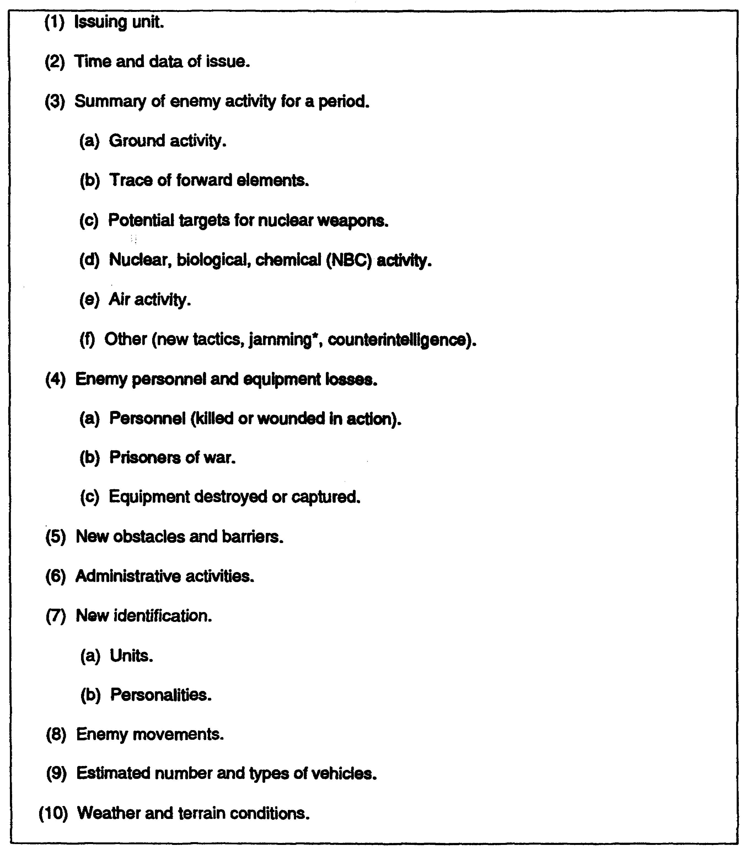

Figure 1-1. Suggested format for the INTSUM.

1-3 IT0113

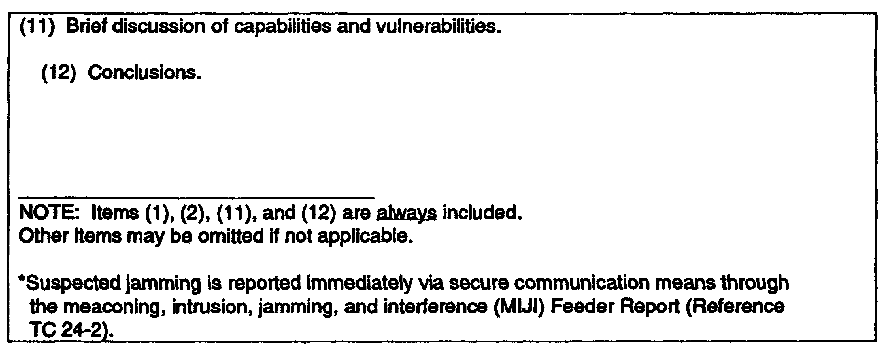

Figure 1-1. Suggested format for the INTSUMs (concluded).

INTSUM Uses. The INTSUM is used to update other major reports of enemy activity such as the intelligence annex, intelligence estimate, and analysis of the area of operations/analysis of battlefield area. It is also used when appraising the enemy situation on a short-term basis. It gives an integrated picture of enemy situation on a short-term basis. It gives an integrated picture of enemy capabilities, vulnerabilities, and activity during the reported period and shows the indicators-weather and terrain-selected to determine the enemy's probable courses of action and conclusions to higher, lower, and adjacent headquarters. The format used by your unit should be spelled out in the unit SOP.

Contents. The INTSUM is constructed from notes, other reports, summaries, messages, maps, and information resulting from liaison visits. Overlays can be included, as required. The INTSUM is usually signed by the S2/G2 or it may have to be approved by the S2/G2 before publication (see SOP).

PART B: INTELLIGENCE ESTIMATE

Description of the Intelligence Estimate. The intelligence estimate is a logical report of your analysis of the intelligence factors affecting your area of operations (AO) and mission. It provides the commander and subordinate intelligence officers with your analysis of enemy strengths and capabilities which may influence the mission.

Purposes of Intelligence Estimate. The purposes are to determine enemy courses of action and the probable order of adoption of these options by the enemy. The four secondary purposes of the intelligence estimate are to:

- Disseminate information and intelligence to higher, lower, and adjacent commands. This includes information on the possible AO and enemy situation.

- Disseminate your assessment of identification, strength, and disposition of enemy forces to subordinate intelligence officers.

IT0113 1-4

- Determine the priority intelligence requirements (PIR) concerning the possible AO and enemy forces which must be collected on before or during operations.

- Identify gaps which may exist in current intelligence holdings.

Preparation. The intelligence officer has the responsibility for keeping the intelligence estimate current. He will receive input from the order of battle (OB) section, analysis and control element (ACE) section chief, and the analysts within your section or center. He is responsible for constantly updating the intelligence estimate. The intelligence estimate is published before moving into the AO. He must present a revised intelligence estimate whenever the situation changes. This assists the commander by providing information he uses to revise his estimate of the situation.

Format (See appendix A for a sample Intelligence Estimate)

Heading consists of the issuing unit, location, date/time group.

Intelligence estimate number.

References include complete map identification information.

Paragraph 1 contains a statement of the unit's mission.

Paragraph 2 consists of your assessment of the AO.

- Subparagraph “a" contains the weather forecast, including light data and the effects of weather and light data on enemy courses of actions. You receive this information from the staff weather officer (SWO) or from higher headquarters.

- Subparagraph "b" contains the terrain analysis. It contains pertinent information on the military aspects of terrain: observation and fields of fire, concealment and cover, obstacles, key terrain features, and avenues of approach (OCOKA), and how these factors affect friendly and enemy courses of action.

- Subparagraph “c" lists all other characteristics of the AO. It contains a discussion on the strategic factors of the area, including information on the affects these factors have on friendly and enemy courses of action.

Paragraph 3 discusses the enemy situation.

- Subparagraph “a" discusses enemy disposition. An overlay from the situation map (SITMAP) can be attached as an appendix showing where known enemy units are located and only referenced in subparagraph “a".

- Subparagraph “b" discusses the composition of enemy units in the AO and includes identified and unidentified units and located and unlocated units.

- Subparagraph “c” discusses the enemy's strength in committed and reinforcing forces. It will also list air, artillery, and nuclear capabilities within the AO.

1-5 IT0113

- Subparagraph “d" lists present and recent significant activities by the enemy within the unit's areas of interest, influence, and operations.

- Subparagraph "e" discusses enemy peculiarities and weaknesses. This includes personnel, intelligence, operations, logistics, and personalities.

Paragraph 4 is your assessment of the enemy's capabilities which includes an enumeration of capabilities, including what units will attack them. A discussion and analysis of each capability are also included.

Paragraph 5 is the conclusion. The probable course of action the enemy is expected to use is presented and the vulnerabilities the enemy presents to your attack forces are discussed in this paragraph.

Items of Note:

- Estimates are only as good as the collected information and intelligence contained in them.

- Coverage must be adequate but limited to the mission of your unit.

- The estimate must be written in a clear, concise manner and as brief as possible.

- References to other documents must be minimized. References may be made to overlays, SITMAPs, or previously published documents from your headquarters.

- Due to the limited assets below division, the intelligence estimate is usually briefed down to battalion as it is received through distribution.

- The commander uses your intelligence estimates when he prepares his estimate of the situation.

You must determine the enemy courses of action and place them in order of priority. You must determine committed and reinforcing forces, and list OB information on disposition, composition, and strength. You also must determine capabilities and vulnerabilities of enemy forces. Your conclusions state what you expect the enemy to do and where the friendly force needs to focus its attention.

PART C: INTELLIGENCE ANNEX

Description of the Intelligence Annex. The intelligence annex is a formal intelligence tasking
and dissemination document which is usually issued as part of the operations order (OPORD),
and operation plan (OPLAN), but can be disseminated separately. It is prepared by the G2/S2.
It can be disseminated separately when time does not permit sending it with the OPORD.

The Intelligence Annex provides the means to:

- Disseminate intelligence information essential to the conduct of operations.

IT0113 1-6

- Announce the commander's priority intelligence requirements and information requirements (PIR/IR).

- Assign information collection responsibilities to subordinate and attached commanders.

- Request information from higher, lower, and adjacent headquarters.

- Provide orders or guidance for handling of enemy prisoners of war (EPW), refugees, captured documents and material, counterintelligence (Cl), and to implement operations security (OPSEC) measures.

- Preserve brevity, clarity, and simplicity of the OPORD.

Format (See appendix B.)

- The heading consists of issuing unit, location, DTG, and message reference number.

- Annex designator and title.

- References completely identify all information on maps enclosed or attached.

- Paragraph 1 contains a summary of the current enemy situation or a reference to the most current intelligence document. An overlay from the SITMAP can also be included.

- Paragraph 2 contains the PIR/IR approved by the commander.

- Paragraph 3 contains information collection tasking for subordinate and attached commanders. Requests for information from higher, lower, and adjacent headquarters are included in subparagraph b.

- Paragraph 4 contains measures for handling personnel, documents, and enemy materiel captured during operations. These instructions supplement those published in the unit SOP.

- Paragraph 5 is a listing by category of equipment and documents required by or allocated to units. It also contains conditions under which equipment or documents will be obtained or required.

- Paragraph 6 contains orders or guidance for CI operations to be conducted in your units AO. It includes any OPSEC measures to be implemented by subordinate units.

- Paragraph 7 contains information which supplements unit SOP for reports, such as when and where reports are to be sent. The division G2 uses this paragraph to change or initiate INTSUM report periods.

1-7 IT0113

- Paragraph 8 lists any additional instructions necessary to accomplish the mission not covered elsewhere.

As a written document, the intelligence annex may be supplemented by the following appendixes:

- Trace.

- Overlay.

- Overprinted map.

- Sketch.

- Plan.

- Table.

- Situation overlay.

- Reconnaissance/surveillance mission instruction document.

- Special and limited Cl set of instructions.

- Remote sensor string emplacements overlay.

- Map distribution table.

Items of Note:

- The annex is kept as brief as possible.

- Matters adequately covered in the unit SOP should not be repeated in the intelligence annex.

- When making references to reports, ensure all units have received their referenced reports.

- List all the current PIR/IR, including those sent out in fragmentary orders (FRAGOs). This document is used to confirm those orders.

The intelligence annex is an integral part of the OPORD. It may be published and distributed with the OPORD or as a separate document. It contains the current enemy situation, either listed or by reference. It lists the PIR/IR approved by the commander and assigns collection tasks to each subordinate or attached commander. It is used to request information from higher, lower, or adjacent headquarters and provide supplemental information on SOP requirements in handling personnel, documents, or materiel captured on the battlefield. It is used to list documents and/or equipment allocated or required by units during an operation. It notes changes to SOP requirements for reports. It can be supplemented with other appendixes

IT0113 1-8

such as a SITMAP overlay or special Cl instructions. The annex is authenticated by the G2/S2 and does not require the commander's signature.

PART D: PERIODIC INTELLIGENCE REPORT

Description of the Periodic Intelligence Report (PERINTREP). Produced at corps and higher headquarters, the PERINTREP covers a specific period, and is normally published every 24 hours, in a tactical situation. This period may vary with the tempo of activity. Corps may dispense with the PERINTREP and publish an INTSUM. Echelons above corps, however, must publish a PERINTREP.

PERINTSUM. In joint operations, a periodic intelligence summary (PERINTSUM) format must be used. This report is detailed in JCS PUB 12.

Format (See appendix C.)

Headings consist of issuing unit, location, DTG, and message reference number.

PERINTREP number.

Period covered will be expressed as DTG.

Disposal instructions. These instructions may consist of time frames or methods of destruction not covered in unit or section SOP.

Paragraph 1 consists of a brief summary of the general enemy situation.

Paragraph 2 consists of a more specific listing of enemy activity:

- Ground.

- Air.

- Airborne.

- Irregular.

- Nuclear, biological, and chemical (NBC) operations.

- Electronic warfare (EW).

- Other, including comments on reserves, reinforcements, new tactics, and equipment

Paragraph 3 includes information from all nine OB categories.

Paragraph 4 contains items of interest to CI. When distribution of this information is limited, it is disseminated in an annex.

1-9 IT0113

Paragraph 5 contains weather information, including effects of weather on operations during that period.

Paragraph 6 contains terrain information. Annexes, overlays, and special maps are used to clarify information which may impact on operations.

Paragraph 7 presents your analysis and discussion of enemy capabilities, vulnerabilities, and your conclusion. The commander's assessment is also reported in the conclusion paragraph.

Study the PERINTREP shown in appendix C.

The PERTINTREP is published at echelons above corps but corps may publish one, if time permits. The PERTINTREP looks at enemy activities on a large scale, and provides OB information to lower commands. Most of the OB information is from sources that lower headquarters do not have access to. It presents the conclusion of the G2 and the commanders assessment of the enemy. Information from reports, summaries, and studies are used to produce the PERINTREP (see appendix D). The PERINTREP is disseminated two headquarters higher and two headquarters lower. If corps publishes a PERINTREP, each brigade receives a copy and copies are also sent to echelons above corps.

PART E: SITUATION REPORT

Description of the Situation Report (SlTREP). The SITREP is a joint report prepared by the G2/S2 and G3/S3. The G2/S2 is responsible for the preparation and/or to provide the information to the G3/S3 for paragraph 1, Enemy. The SITREP is prepared by the G3/S3 as often as the commander designates or as is required in accordance with the unit SOP.

This Subcourse Discusses Paragraph 1 Only. The remainder of the SITREP is the responsibility of the G3/S3. A sample of this portion of the SITREP is in appendix A of FM 34-3.

Format (See appendix E.)

- Subparagraph "a” lists enemy units in contact. This list includes the locations of known enemy units.

- Subparagraph “b" lists enemy units in reserve which can affect the mission.

- Subparagraph “c" is a brief description of enemy activities during the reporting period.

- Subparagraph “d" is an estimate of the enemy's strength, morale, and possible enemy knowledge of the friendly situation.

- Subparagraph “e” is your conclusion concerning enemy probable courses of action.

SITREP Distribution. If time permits, the SITREP is sent through regular distribution to higher headquarters. The part of the SITREP which this subcourse is concerned with may be disseminated as an annex or several annexes depending on the amount of information to be sent.

IT0113 1-10

The G2/S2 reports enemy units in contact (strength and disposition), morale, and possible enemy knowledge of the friendly situation.

The purpose of the report is to pass information concerning the tactical situation and any administrative details which may affect the mission (such as casualty reporting). The G3/S3 is the primary writer of this report. The G2/S2 furnishes G3/S3 the information to put in paragraph 1, or prepares paragraph 1 and sends it to G3/S3 for inclusion in the SITREP.

PART F: SITUATION OVERLAY

Description of the Situation Overlay. The situation overlay can be attached to a report (such as an intelligence estimate or PERINTREP) or it can substitute for a report, such as a SITREP. However, the situation overlay is normally an annex to a report. It is a graphic depiction of the enemy or friendly situation or of both enemy and friendly situations.

Preparation. All overlay preparation is in accordance with chap 7 of FM 21-26 and Fm 101-5-1.

Items of Note:

- Use grid references or registration marks on the overlay. This facilitates orienting the overlay to the map.

- Use appropriate colors when plotting information. When color pencils or markers are not available, use double lines to indicate enemy positions.

- Use appropriate military symbols when plotting information. All symbology used in plotting should be explained in the legend IAW FM 101-5-1.

- Include a map reference in the legend. An overlay is useless if it cannot be placed over the appropriate map to determine terrain effects on disposition of enemy and/or friendly forces.

- Place the classification at the top and bottom of the overlay and in the marginal information when the overlay is classified. If it is to be rolled or folded, the classification must be on the outside where it can be easily seen or stamped with additional classification markings after rolling or folding.

- The center of mass of the symbol when plotting is the center of the coordinates of identified unit location or the location of important piece(s) of equipment.

- When posting information on the situation overlay, post enemy units at your echelon, and two echelons below and one above you.

PART G: ANALYSIS OF THE AREA OF OPERATIONS

Description of the AO Analysis. The AO analysis is an extract of the analysis of the battlefield area, and is a comprehensive study of a possible area of operations. It contains information gathered from intelligence preparation of the battlefield (IPB) with emphasis on weather and terrain.

1-11 IT0113

The commander uses this AO analysis to determine the effects of the AO on both enemy and friendly forces.

Cooperation. The AO analysis is produced by the G2/S2 and based on the mission of the unit. The commander provides a mission statement and the G2/S2 receives assistance from other staff officers or headquarters during the preparation of the AO analysis:

- The engineer officer supplies terrain analysis.

- The SWO provides weather and light data.

- The civil-military operations (CMO) officer or G5/S5 provides information on sociology, politics, economics, psychology, technology, and related fields.

- The CMO and civilian personnel offices provide information on local labor conditions.

- The provost marshal provides information on route reconnaissance and rear area threat.

- The corps G2 provides most of the preprocessed information on terrain, weather, route reconnaissance, social, political, and labor within the AO when other staff officers are not available.

- Studies by EAC also provide information upon request, if the information is available or is deemed necessary.

Preparation normally occurs with the receipt of an actual mission; however, it may be prepared before receipt of mission, if a logical mission can be assumed. You may be required to produce a new analysis or update the existing one when the mission changes, when new decisions are made, or more accurate information is received.

Format (See appendix G.)

The heading consists of the issuing section and headquarters, location, and DTG.

Report identifier, with number, is noted.

The reference contains complete map identification data.

Paragraph 1 contains information on the purpose and any limiting considerations.

The purpose includes all details of the area being studied.

Paragraph 2 contains information on the general description of the area. You will provide information on the weather's effect on terrain as well as NBC munitions effects. Also, terrain information may be in the form of annexes, for example, overlays and maps, relief and drainage, vegetation, surface materials, and man-made features. In addition, subparagraph 2C, Additional Characteristics, contains information on sociology, politics, economics, religion, psychology, transportation, manpower, culture, and hydrography.

IT0113 1-12

Paragraph 3 contains your analysis of the information contained in paragraph 2. It includes information on two types of military aspects of the area:

Tactical aspects are broken down into five areas: observation and fields of fire, concealment and cover, obstacles, key terrain features, and avenues of approach.

Combat Service Support Aspects. Analyze the same information as in tactical aspects, but for supply, personnel, and CMO movement.

Paragraph 4 contains the effects of characteristics of the AO analysis of paragraphs 2 and 3.

- List the effects of the AO on enemy courses of action.

- List the effects of the AO on friendly courses of action.

At corps, a written analysis of the AO is produced. At division or below, an abbreviated form included in the intelligence estimate is used. At division, a written analysis is usually prepared for future operations or when changes in mission, enemy, or environment make the old one obsolete. Most of the information concerning weather and terrain is developed during IPB. IPB is discussed in Subcourse IT0462 and FM 34-3.

PART H: INTELLIGENCE BRIEFING

TYPES OF BRIEFING

There are four types of briefing:

- Information.

- Decision.

- Mission.

- Staff.

Only three types of briefings will be discussed in this lesson: information, decision, and staff.

Information Briefing. The information briefing—

- Informs the listener.

- Is brief.

- Deals primarily with facts.

- Does not include conclusions, recommendations, or require decisions.

Your briefing should follow the format shown below:

1-13 IT0113

Introduction

- Greeting.

- Self-identification.

- Purpose of the briefing.

- Procedures. (Use only when briefing more than one subject.)

Body

- Summary of known information.

- New information.

- Speak in a clear, concise, and professional manner.

- Use visual aids to focus on the main point.

The sequence will be repeated for each main topic you are presenting. You may tie the main topics together.

Closing

- Ask your audience for questions and attempt to answer all questions fielded. If for some reason you cannot answer a question, tell the person you will find it and get back to him.

- Concluding statement. State the purpose of the briefing again or give a summary of the main idea(s) from the body.

- Announce the next briefer, if any.

The information briefing presents intelligence information on—

- Estimates.

- Analysis.

- Current OB holdings.

- Situation summaries.

Decision Briefing is used to obtain an answer or a decision. It is used to—

- Obtain a decision.

IT0113 1-14

- Give facts, recommendations, and conclusions for the commander on which to base his decision.

- Present a completed staff study.

Format is essentially the same as the information briefing but contains some differences in the body of the briefing. Facts and recommendations will be presented in the body of the briefing and the conclusion, or decision if a decision has been reached in the closing of the briefing.

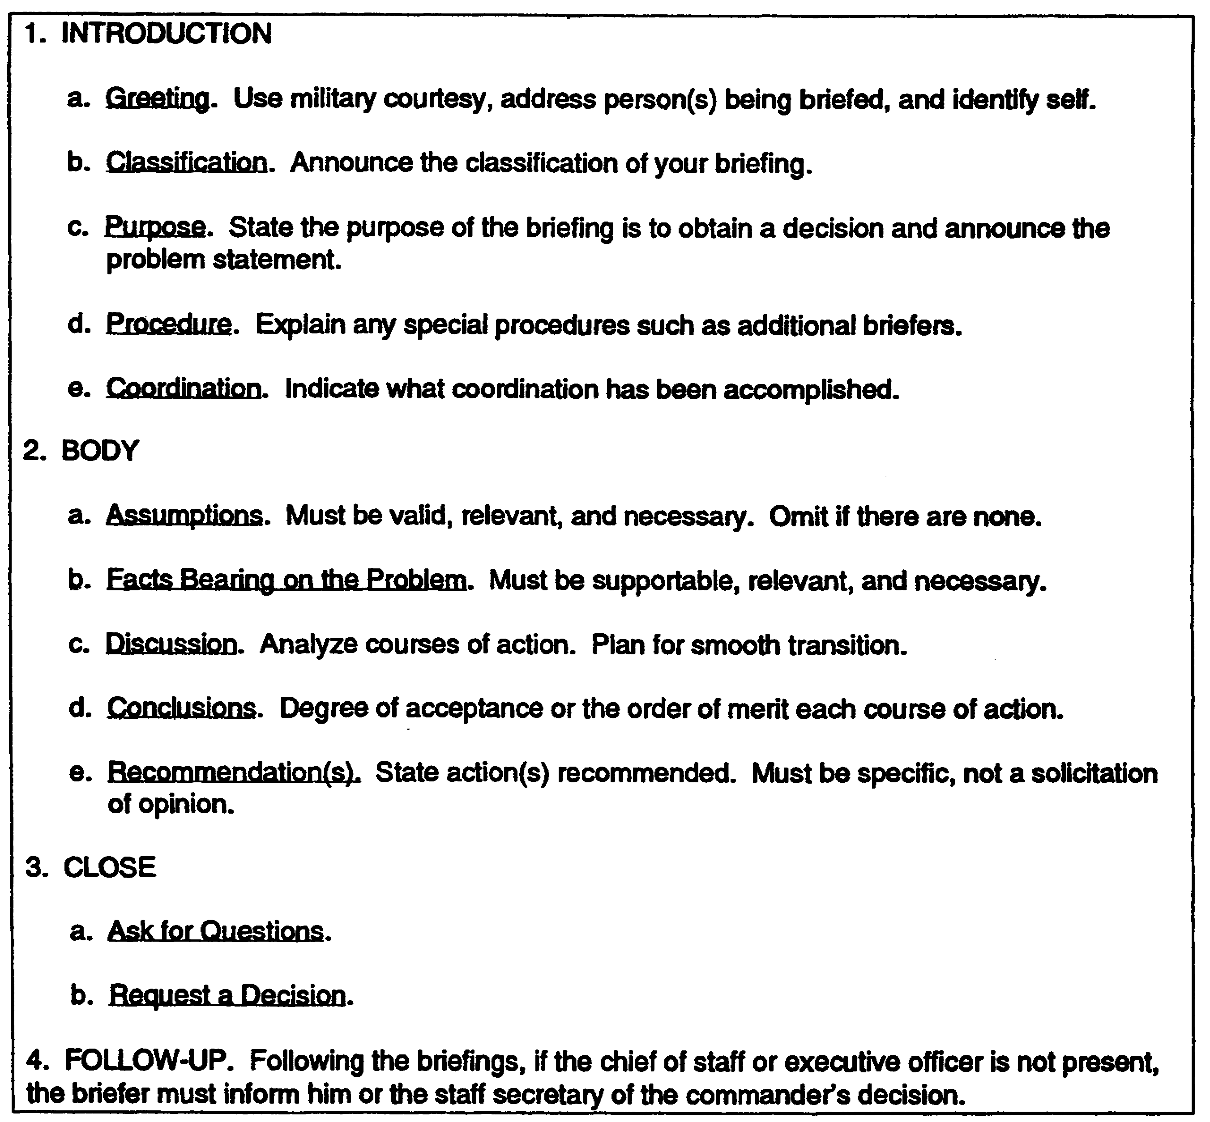

Figure 1-2. Decision Briefing Format.

Staff Briefing is usually chaired by the chief of staff at division and above. It is chaired by the executive officer at brigade and below. In a staff briefing, each major section of a unit may be called on to present items of information affecting a subject or course of action. The purpose of

1-15 IT0113

the staff briefing is to secure a unified effort. Each staff officer may give his estimate of a situation or course of action. The commander may render a decision at the end of the briefing or at a later date based on information given in a staff briefing.

Preparing a Briefing. The following are the major steps in preparing a briefing:

Situation Analysis

Audience

Size

Nature

- Who composes the audience?

- Is only one service involved?

- Are civilians or foreign nationals present?

- Who are the ranking members?

- What are their official positions?

- Where are they assigned?

- How much professional knowledge of the subject do they have?

- Are they generalists or specialists?

- What are their interests?

- Personal preferences?

- What is the anticipated reaction?

Purpose and Type

- Information briefing.

- Decision briefing.

- Staff briefing.

- Mission briefing.

Subject

- Specific subject.

IT0113 1-16

- Desired coverage.

- Time allocated.

Physical Facilities

- Where will the briefing be presented?

- What arrangements will be required?

- What are the visual aid facilities?

- What are the deficiencies?

- What actions are needed to overcome deficiencies?

Schedule of Preparatory Effort

- Complete analysis of the situation.

- Prepare preliminary outline.

- Determine requirements for training aids, assistants, and recorders.

- Edit, redraft, or both.

- Schedule rehearsals (facilities, critiques).

- Arrange for final review by responsible authority.

Constructing the Briefing

Collect material

- Research.

- Become familiar with subject.

- Collect authoritative opinions and facts.

Prepare First Draft

- State problem, if necessary.

- Isolate key points.

- Select courses of action.

1-17 IT0113

- State advantages and disadvantages. Analyze and compare.

- Determine conclusions and recommendations.

- Prepare draft outline.

- Include visual aids.

- Fill in appropriate material.

- Review with appropriate authority.

Revise first draft and edit

- Make sure facts are important and necessary.

- Include all necessary facts.

- Include answers to anticipated questions.

- Polish material.

Plan use of visual aids

- Check for simplicity and readability.

- Develop method for use.

Practice

- Rehearse with assistants and visual aids.

- Polish briefing.

- Isolate key points.

- Memorize outline.

- Develop transitions.

- Use definitive words.

Delivery

Posture

- Military bearing.

- Significant movement.

IT0113 1-18

- Eye contact

- Gestures.

- Mannerisms.

Voice

- Pitch.

- Volume.

- Rate.

- Variety.

- Enunciation.

Attitude

- Businesslike (military bearing).

- Helpful.

- Natural humor.

- Confident.

- Answer questions.

Follow-up

Ensure understanding.

Record decision.

Inform proper authorities.

You have been provided with the major steps in preparing the three most common types of military briefings. Rehearsal is imperative for a successful presentation. At the conclusion of your briefing, always follow up on questions or information requested. For more information on briefing techniques see FM 34-3.

1-19 IT0113

LESSON 1

PRACTICE EXERCISE

The following items will test your grasp of the material covered in this lesson. There is only one correct answer for each item. When you have completed the exercise, check your answers with the answer key that follows. If you answer any item incorrectly, study again that part of the lesson which contains the portion involved.

1. How many areas will the tactical aspects of an area be broken down into?

A. Three.

B. Five.

C. Six.

D. Four.

2. When will most of the information on weather and terrain be developed?

A. IPB.

B. Terrain analysis.

C. Route reconnaissance.

D. AO analysis.

3. What should you always do after a briefing has been concluded?

A. Thank the participants for attending.

B. Follow up on the questions or information requested.

C. Provide refreshments.

D. Solicit opinions from friends on how well you did.

4. When should the INTSUM be published?

A. Every 6 hours.

B. Every 24 hours.

C. Weekly.

D. All of the above.

IT0113 1-20

5. In the suggested format, what does paragraph 4 of the INTSUM concern?

A. Enemy activities.

B. Obstacles and barriers.

C. Enemy movements.

D. Enemy personnel and equipment losses.

6. As the G2/S2 of a unit, what should you do to the INTSUM before it is published?

A. Brief it

B. Classify it.

C. Check the SOP.

D. Approve and sign it.

7. What are the three reports the INTSUM may update?

A. Key terrain reports, obstacle reports and intelligence annex.

B. Intelligence annex, intelligence summary and obstacle overlay.

C. Intelligence annex, situation report and intelligence briefings.

D. Intelligence annex, intelligence estimate and analysis of the area of operations.

1-21 IT0113

LESSON 1

PRACTICE EXERCISE

ANSWER KEY AND FEEDBACK

Item Correct Answer and Feedback

1. B. Five. (page 1-13)

2. A. IPB. (page 1-11/12)

3. B. Follow up on the questions or information requested. (page 1-19)

4. E. All of the above. (page 1-2)

5. D. Enemy personnel and equipment losses. (page 1-3)

6. C. Approve and sign it. (page 1-4)

7. D. Intelligence annex, intelligence estimate and analysis of the area
of operations. (page 1-4)

IT0113 1-22

LESSON 2

INTELLIGENCE INFORMATION REPORT DISSEMINATION

CRITICAL TASKS: 301-372-2250
301-372-3300
301-372-3301

OVERVIEW

LESSON DESCRIPTION

This lesson will teach you how to disseminate intelligence information and reports/studies according to unit SOP.

TERMINAL LEARNING OBJECTIVE

TASK: You will disseminate intelligence reports and information according to unit SOP.

CONDITION: You will be given narrative information and examples from AR 105-31, AR 380-5, FM 34-1, FM 34-3, FM 34-130, and FM 101-5.

STANDARD: You will complete the practice exercise to 100 percent accuracy.

REFERENCES: The material contained in this lesson was derived from the following publications:

AR 105-31
AR 380-5
FM 34-1
FM 34-3
FM 34-130
FM 101-5

INTRODUCTION

This lesson discusses dissemination methods as they pertain to intelligence information and reports.

This lesson provides guidance for the dissemination of intelligence and combat information via reports and studies. Emphasis is on the reports discussed in lesson 1. Dissemination will focus at brigade, division, corps, and army/theater levels.

INFORMATION DISSEMINATION

Intelligence information is of little value unless it is disseminated promptly, accurately, and in a usable format. Collected enemy intelligence is of no value to the commander unless he receives it in time to make his decisions.

2-1 IT0113

Dissemination Methods. Several of the most common dissemination methods are—

- Personal contacts.

- Message center distribution.

- Oral reports.

- Electrical transmission.

- Radiotelephone transmissions.

Personal Contact between the G2/S2 and other staff sections is paramount to keeping a two-way dialogue open. You need to inform other staff officers of changes in the enemy's forces. You also need to know what the other staff sections information needs are. These contacts are also called liaisons.

Your noncommissioned officer (NCO) or you conduct personal contacts with other staff sections, subordinate units, and higher, cooperating, and adjacent headquarters. Use these contacts to—

Disseminate collected and processed intelligence information.

Conduct advance planning for future operations.

Initiate fragmentary orders.

Coordinate modifications in intelligence and security operations.

Ensure understanding and successful execution of the commander's collection orders.

Develop and collect information of the enemy situation as rapidly and completely as possible.

Facilitate the exchange of intelligence and information, especially during rapidly changing battlefield situations.

Message/Distribution Center System. Almost all units use a message/distribution center system for routine information distribution within their headquarters, and to higher, cooperating, or adjacent headquarters. These centers handle official documents, reports, and other material.

The flow of intelligence generally follows this scheme. Your section prepares the report in its proper format and in sufficient copies. Your unit SOP furnishes a guideline for the number of copies needed. Keep one copy for your files after the report has been approved. The completion, approval, and disposition of the report are logged in the sections or headquarters journal. The completed report may either be hand-carried or picked up by message/distribution center personnel. Your unit SOP will detail procedures for logging and receipting material.

Whether intelligence reports are disseminated internally or externally, you must afford adequate protection consonant with the degree of security classification of the report.

IT0113 2-2

All personnel handling the document must have the appropriate security clearance and a need-
to-know. It is also your responsibility to ensure proper procedures are used for transmitting
classified material. This is detailed in your unit's SOP and AR 380-5.

Oral Report. Oral reports present information to the commander, staff, or designated audiences. They may be—

- Informal.

- Spontaneous.

- Very brief.

- Presented when urgency of information precludes a written report.

Oral reports will be followed up with a memo or written report as soon as practical.

Oral reports may be given in your immediate work area, or you may be called to the commander to give the report.

Electric Transmission. With the battlefield becoming more and more complex, the need for long-range communication becomes of greater importance. One of the most common secure methods of transmitting critical, immediate, and valuable information messages is through the use of the electrical telecommunication system.

Every unit has access to some type of telecommunication system. The most common is the communication center (COMMCEN) which transmits messages via radio teletype. On a large post such as Fort Bragg, NC, one large COMMCEN services all tenant units. When a unit is tactically deployed, a tactical COMMCEN may go with it. Many units have their own organic mobile COMMCEN, usually a van or communication shelter, mounted on a truck.

Electronic Satellite Microwave Communications. Intelligence products to be electrically transmitted must be prepared in a prescribed format to facilitate processing and transmitting by the COMMCEN. Messages must be prepared on DD Form 173 or equivalent in accordance with AR 105-31. Individuals primarily responsible for the preparation of an electrically transmitted message are the originator, drafter, and releaser.

The originator is either your commander, G2/S2, or other authority who directs a message to be transmitted. Normally it will be the commander.

The drafter writes the message and has more responsibility in message preparation than the originator or releaser. He is responsible for:

- Complying with all pertinent regulations and directives.

- Ensuring messages are brief, clear, and concise.

- Assigning proper security classification.

2-3 IT0113

- Obtaining necessary staff coordination.

- Ensuring priority messages are handled expeditiously.

The releaser provides final administrative review and approval. The releaser can be any person the commander or originator designates to release messages.

Precedence categories are used to indicate—

- The relative order in which the message is processed by the COMMCEN.

- The speed in which the message will be handled during staff coordination process.

Precedence determines the time from when the message is initially filed at the originator's COMMCEN to when it is available for delivery to the addressee by the receiving COMMCEN. Precedence categories and their time objectives are as follows:

PRECEDENCE CATEGORY TIME OBJECTIVE

(1) FLASH As rapidly as possible with an
objective of less than 10 minutes.

(2) IMMEDIATE 1 hour

(3) PRIORITY 3 hours

(4) ROUTINE 6 hours

FLASH Precedence: Reserved for initial enemy contact messages or operational combat messages of extreme urgency.

Brevity is mandatory. Example are:

- Initial enemy contact reports.

- Warning of imminent large-scale attacks.

- Extremely urgent or critical intelligence messages.

IMMEDIATE Precedence: Reserved for messages on a situation which gravely affects the security of national or allied forces, or populace and requires immediate delivery to addressees.

Examples are:

- Reports of initial enemy contact

- Reports of unusual major movements of foreign powers in times of peace or strained relations.

- Messages which report enemy counterattacks.

IT0113 2-4

- Urgent intelligence messages.

- Reports of widespread civil disturbance or grave natural disasters.

PRIORITY Precedence: Reserved for messages which require expeditious action by addressee and/or furnish essential information for conduct of operations in progress. Examples are:

- SITREPs on position of the front where an attack is impending.

- Important intelligence messages.

ROUTINE Precedence: Used for all types of messages that justify transmission by electrical means. These are not of sufficient urgency or importance to require a higher precedence.
Examples are:

- Projected operations plans.

- Periodic or consolidated intelligence reports.

- Administrative, logistics, and personnel matters.

See AR 105-31 for more information.

Disposition of Message. Once the message has been approved and released, it is taken to the COMMCEN for transmission. Actual distribution to the COMMCEN will be determined in your unit SOP. During distribution:

- Safeguard the message in accordance with its degree of security classification.

- Log the message in the section journal.

- Log and obtain a receipt as required in SOP.

- Be aware of the precedence category of the message.

Tactical messages may be handwritten. These messages do not need to be written on a DD Form 173. An alternate internal form may be provided at brigade and battalion for writing these messages. In this case, the originator coordinates with the unit for acceptance of the form.

The Ml battalion (Ml Bn) has an organic telecommunication center (TCC). The center supports the special security officer of the division G2. The battalion has radio teletypewriter (RATT) communication facilities for sending messages to the brigades or to corps. The RATTs are located with the tactical command post section, ACE, and the battalion tactical operations center (BTOC). The TCC is normally located with the all-source Intelligence section (ASIS).

Radio/Telephone Transmission. The fastest battlefield means of communication are FM radio and land-line telephone. In an accelerated tactical situation, radios may be your only communication means. These communication means may be secure or nonsecure and rely

2-5 IT0113

heavily on good COMSEC procedures for continuous operation. A field telephone also can be used in a static situation when the signal personnel have emplaced land-lines. This is the most insecure form of battlefield communication. Regular phone systems can be used only in a permanent or semipermanent location and when military or commercial lines are available. Using commercial telephone systems and field telephones are the least secure communication means.

Radio Communication. FM radio is probably the fastest communication means. However, radio traffic is broadcast to anyone who has a radio that can match your frequency. If you do not have the means to secure FM transmissions, the radio audience may include:

- The enemy.

- Anyone else within radio range as well as the unit you are transmitting to.

There are several ways to minimize the amount of radio traffic the enemy can intercept:

- Use proper radio COMSEC procedures.

- Use proper OPSEC measures, such as challenge and authentication procedures.

- Keep radio transmissions short and to the point.

- Use encryption procedures properly and whenever called for.

Rules to follow when disseminating intelligence information by radio are:

Make only authorized transmissions. Avoid unnecessary calling, testing, and readability reports. Say only what has to be said.

Listen in before transmitting. Failure to listen in before transmitting causes confusion, loss of time, and makes more transmission necessary.

Answer promptly. All transmissions requiring an answer should be answered right away. If you are unable to accept traffic, answer the call with the proword HALT, followed by the ending sign OUT.

Transmit slowly. Transmit at a speed the slowest operator in your radio net can copy.

Send clearly. Jerky transmissions or clipped speech are difficult to understand.

Use standard phrases and terms.

Use the phonetic alphabet to transmit code groups and individual letters of the alphabet or to spell out difficult or unfamiliar words. A review of the phonetic alphabet follows:

IT0113 2-6

LETTER WRITTEN AS LETTER WRITTEN AS

A . . . . Alpha N . . . . November

B . . . . Bravo O . . . . Oscar

C . . . . Charlie P . . . . Papa

D . . . . Delta Q . . . . Quebec

E . . . . Echo R . . . . Romeo

F . . . . Foxtrot S . . . . Sierra

G . . . . Golf T . . . . Tango

H . . . . Hotel U . . . . Uniform

I . . . . India V . . . . Victor

J . . . . Juliette W . . . . Whiskey

K . . . . Kilo X . . . . Xray

L . . . . Lima Y . . . . Yankee

M . . . . Mike Z . . . . Zulu

To send classified or "For Official Use Only" information over the radio, your communication-electronics (C-E) officer provides you with simple operations codes to encode a part or all of your transmissions. These codes contain instructions on decrypting encoded messages. Your C-E officer also provides you with the necessary daily challenge and authentication tables you need to transmit traffic.

Tactical radios, such as the SINGARS, can have additional equipment attached to them that permits transmission of classified information in clear text. This additional equipment scrambles your voice into an unintelligible signal before transmitting it over the airwaves. Only if the unit receiving your message has similar equipment will the transmission be intelligible.

A relatively lengthy message should be transmitted via electronic satellite communications or sent by messenger rather than transmitted by radio means.

Telephone Communication. Less precautions are needed when using land lines. However, the enemy can splice into the lines or cables to intercept your message. Splices can be easily traced and removed. The longer the distance between the receivers and transmitters, the greater the chance for interception. When using long-range telephone land line communication, remember that radio (microwave) is generally used to span large areas and is easily intercepted.

2-7 IT0113

Telephone communication cannot penetrate enemy territory. Cables can be destroyed by one shell, or weather, or wildlife can break or chew through the cable.

Classified information should not be sent over the telephone. If it is unavoidable, the C-E office will furnish a suitable operational code. If secure telephone circuits are available at your headquarters, use them for all classified conversations.

Mail/Courier/Messenger Service.

Mail. During peace and times of heightened tension, you may use the US mail for dissemination of intelligence products.

Intelligence products sent by US mail must meet the criteria and restrictions outlined in AR 380-5 and your unit SOP.

Important considerations for mailing classified material are:

Classification Restrictions

TOP SECRET documents cannot be mailed via US Postal Service (USPS) channels.

SECRET may be mailed via USPS registered mail only within and between the US and its territories.

SECRET material may also be sent by USPS registered mail through Army, Navy, or Air Force Postal Service (APO) /Fleet Post Office (FPO) outside the area described above, provided the material does not at any time pass out of US citizen control and does not pass through a foreign postal system.

Secret documents send to and from the US government and/or a Canadian government installation located in the US or Canada can be sent through USPS registered mail with registered mail receipt requested.

CONFIDENTIAL material can be sent through USPS first class mail channels between Department of Defense (DoD) component locations within and between the US and its territories. However, the outer envelopes or wrappers of such confidential material shall be endorsed "Postmaster Do Not Forward Outside Areas Served By US Civil Post Officers." Registered mail is used for material directed to DoD contractors.

Use USPS registered mail for CONFIDENTIAL material sent-

- To NATO.

- To and from APO and FPO addressees located outside the area set forth above.

- To other addressees when the originator is uncertain if their location is within the US boundaries. Use of return postal receipts on a case-by-case basis is authorized.

- COMSEC information as prescribed in AR 380-40 and Technical Bulletin 380-41.

IT0113 2-8

Courier Service. In certain overseas areas and at major headquarters, the Armed Forces Courier Service (ARFCOS), an official military courier service, is available to physically transport classified material to other locations. ARFCOS is available only in certain select areas worldwide. Consult the G2/S2 and your unit SOP to determine availability of ARFCOS in your area and whether your unit uses ARFCOS to disseminate intelligence. All material to be transmitted will be prepared in accordance with sec 2, chap 8, AR 380-5.

Messenger Service. Rather than rely on ARFCOS or a mail distribution systems, many units use unit personnel as messengers to disseminate their intelligence products. These messengers may be assigned to the unit headquarters and dispatched either on an "as-needed" basis or follow a regular messenger schedule. Messengers must possess security clearances as high as the material they will be delivering, and the intelligence products must be packaged in the same manner as required for mailing. Messengers may act as couriers for classified material when an appropriate official has so authorized him to be a courier. See sec 3, chap 8, AR 380-5 for further information.

Dissemination of Intelligence Reports

The INTSUM is produced at each level up to and including corps. It is disseminated to higher, lower, and adjacent headquarters. Normally one copy is sent to each headquarters.

The Intelligence Estimate may be produced at all levels but is required only at division level and above. It is disseminated to higher, lower, and adjacent headquarters. Within the division, the intelligence estimate may be briefed down to battalion. Again, normally one copy is sent to each headquarters.

The Intelligence Annex is produced at each level and is an integral part of the OPORD. It is disseminated the same as the OPORD.

The PERINTREP is produced at corps and Army/Theater levels. It is disseminated two above and two below the originating echelon.

The SITREP is the overall responsibility at each echelon of the G3/S3 and disseminated to the next higher echelon. (Paragraph 1 of the SITREP is prepared by the G2/S2.)

The Situation Overlay is prepared at division, corps, and Army/Theater levels. This analysis is usually disseminated to lower headquarters.

Dissemination at Division. The division has a telecommunication center which is sited by the signal battalion. The forward company of the signal battalion supports the brigade. The signal battalion provides electronic satellite, microwave and radio communication for the division headquarters and brigades. The forward companies of the signal battalion supply telecommunication and messenger service for limited distribution message, multichannel communication, telephone systems, and cable and field wire installation for communication outside the brigades. The division G1 operates a mail and distribution center for all reports and material being sent to higher, lower, and adjacent headquarters.

2-9 IT0113

Normally distribution is picked up from and delivered to the G1 distribution center. Message traffic is delivered to the COMMCEN for transmission. Your section does this and also picks up incoming classified messages.

Brigade dissemination procedures are basically the same as division distribution procedures. Information is transmitted to battalion via FM radio and electronic and satellite. Routine material is generally sent by messenger/courier. This holds true below battalion also.

Dissemination at Corps. The corps has a signal brigade which provides the same service as the signal battalion does at division. The G1 provides a mail and distribution center for unclassified routine reports and material.

Dissemination at Army/Theater. The Army/Theater has one or more signal commands which provide the same services as the signal brigade does at corps. The G1 provides a mail and distribution center for unclassified routine reports and material.

Dissemination in the Battalion. In the Ml battalion (DIV) dissemination is handled mostly through the division distribution system. The battalion has organic communication equipment for dissemination within the division area and electronic and satellite equipment for dissemination to higher lower, and adjacent headquarters. Each element can communicate with battalion through battalion FM radio nets.

The Ml Brigade (CORPS) uses the corps satellite communication and distribution systems. The brigade has organic equipment for communication between its battalions including radio and satellite networks. Telecommunication facilities are available at brigade headquarters or corps.

There are many ways to disseminate intelligence information, reports, and studies. Once messages or reports are approved, they must be properly disseminated. You are responsible for checking the unit SOP for dissemination instructions, reproducing the message or report in sufficient copies, placing a copy in your files, and for placing the remaining copies in distribution, or hand carrying them to the transmission point. You are also responsible for recoupling the transmission of the message with the information in the section's journal.

IT0113 2-10

LESSON 2

PRACTICE EXERCISE

The following items will test your grasp of the material covered in this lesson. There is only one correct answer for each item. When you have completed the exercise, check your answers with the answer key that follows. If you answer any item incorrectly, study again that part of the lesson which contains the portion involved.

1. Who is the person who writes or drafts a message?

A. Drafter.

B. Originator.

C. Releaser.

D. Commander.

2. To which elements do the signal battalion provide communications support?

A. Battalions.

B. Brigades.

C. Companies.

D. Corps.

3. Unless otherwise specified in the unit SOP, what form are most messages prepared on?

A. DS Form 789.

B. DD Form 173.

C. DF Form 526.

D. DM Form 012.

4. What can coordination between internal staff sections best accomplish?

A. Personal contacts.

B. Teletypewriter transmission channels.

C. Messengers.

D. FM radio nets.

2-11 IT0113

LESSON 2

PRACTICE EXERCISE

ANSWER KEY AND FEEDBACK

Item Correct Answer and Feedback

1. A. Drafter. (page 2-3)

2. B. Brigades. (page 2-9)

3. B. DD Form 173. (page 2-3)

4. A. Personal contacts. (page 2-2)

IT0113 2-12

